Topics: Descriptive Statistics and Probability

- Look at the data given below. Plot the data, find the outliers and find out $μ, σ, σ^{2}$

Name of company | Measure X
Allied Signal | 24.23%
Bankers Trust | 25.53%
General Mills | 25.41%
ITT Industries | 24.14%
J.P.Morgan & Co. | 29.62%
Lehman Brothers | 28.25%
Marriott | 25.81%
MCI | 24.39%
Merrill Lynch | 40.26%
Microsoft | 32.95%
Morgan Stanley | 91.36%
Sun Microsystems | 25.99%
Travelers | 39.42%
US Airways | 26.71%
Warner-Lambert | 35.00%

Ans : Added in Jupiter notebook

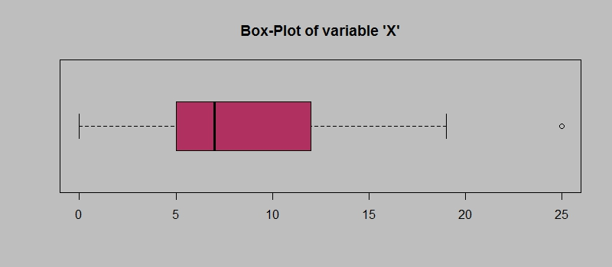
Answer the following three questions based on the box-plot above.
- What is inter-quartile range of this dataset? (please approximate the numbers) In one line, explain what this value implies.

- What can we say about the skewness of this dataset?
- If it was found that the data point with the value 25 is actually 2.5, how would the new box-plot be affected?

Ans:
- IQR = Q3 – Q1 = 19-5 = 14.
This tells how spread out the middle 50% of values are in a given dataset
- Here the median is closer to lower end of boxplot and upper whisker is longer than the lower one, Hence this is Right skewed
- Then there will b no outliers

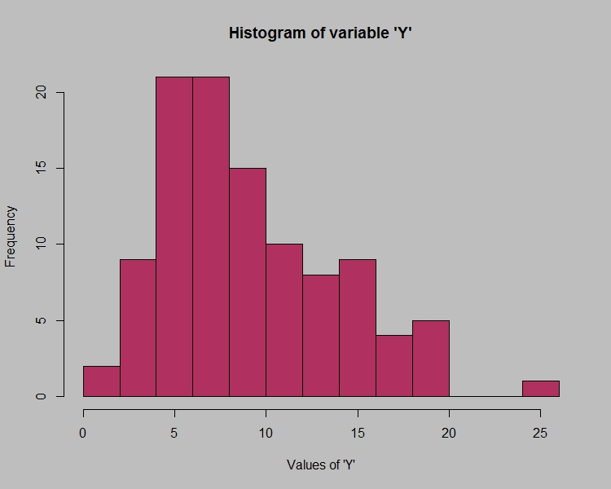

Answer the following three questions based on the histogram above.
- Where would the mode of this dataset lie?
- Comment on the skewness of the dataset.
- Suppose that the above histogram and the box-plot in question 2 are plotted for the same dataset. Explain how these graphs complement each other in providing information about any dataset.

Ans:
- Modal class with highest frequency of above 20 that is 3rd and 4th bar in the histogram is the mode lie
- Since the tail is towards right side of histogram, it is positively skewed
- Both the graphs are right skewed

- AT&T was running commercials in 1990 aimed at luring back customers who had switched to one of the other long-distance phone service providers. One such commercial shows a businessman trying to reach Phoenix and mistakenly getting Fiji, where a half-naked native on a beach responds incomprehensibly in Polynesian. When asked about this advertisement, AT&T admitted that the portrayed incident did not actually take place but added that this was an enactment of something that “could happen.” Suppose that one in 200 long-distance telephone calls is misdirected. What is the probability that at least one in five attempted telephone calls reaches the wrong number? (Assume independence of attempts.)

Ans:
Prob of call misdirected = 1/200 = p
Prob of calls not misdirected = 1 – 1/200 = 199/200 = q
Atleast one in 5, so n = 5, x=1

P(x) = ^{n}c_{x} * p^{x} * q^{n-x}
p(1) ⁼ ⁵c_{1 * (1/200)^1 * (199/200)^5-1}
_{p(1) =0.0255}
_{0.0255*100= 2.55}
so atleast 2 calls reaches wrong numbr

- Returns on a certain business venture, to the nearest $1,000, are known to follow the following probability distribution
x | P(x)
-2,000 | 0.1
-1,000 | 0.1
0 | 0.2
1000 | 0.2
2000 | 0.3
3000 | 0.1

- What is the most likely monetary outcome of the business venture?
- Is the venture likely to be successful? Explain
- What is the long-term average earning of business ventures of this kind? Explain
- What is the good measure of the risk involved in a venture of this kind? Compute this measure

Ans:
- Most likely monetory outcome is 2000$, t and the probability is 0.3,which is maximum as compared to others
- P(x>0) + p(x>1000)+p(x>2000)+p(x>3000) =
0.2 + 0.2 + 0.3+ 0.1 = 0.8
0.8 *100 = 80% chances for making profit

- E(X) = sum(x*p(x)) = 800
- 1870$

